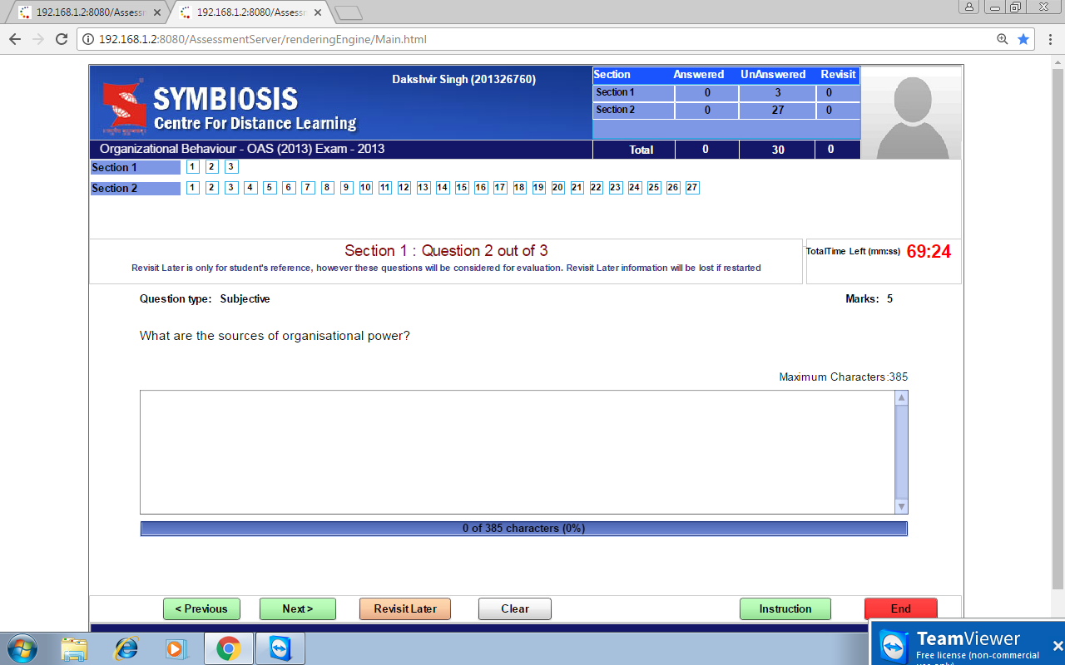

Five sources of power in an organization are

1) Legitimate Power-Legitimate power is also known as positional power.

2) Expert Power-is that kind of power which an employee has due to the knowledge and expertise that he/she possesses.

3) Coercive Power-Coercive power is the power that a person has which he/she uses to coerce or threaten other employees

4) Referent power-The relationships that a person develops with co-workers and the charisma with which a person is able to present himself.

5) Reward Power-Reward power arises out of the authority that a person has to recognise and reward people.
